East Area Planning Committee | - 3rd August 2011

Application Number: | 11/01681/FUL
Decision Due by: | 20th September 2011
Proposal: | Proposed redevelopment to provide 58 ensuite student rooms with shared facilities and wardens room on three floors
Site Address: | The Cavalier Public House 148-150 Copse Lane  (Site Plan – Appendix 1)
Ward: | Headington Hill And Northway Ward

Agent: | John Philips Planning Consultancy | Applicant: | I And O Ltd.

Recommendation: Resolve to grant planning permission and delegate authority to officers to issue the decision notice upon completion of the Legal Agreement for the following reasons:

1 The principle of development was established under planning permission reference 10/03215/FUL. The principle of student accommodation and the loss of the public house has been accepted in accordance with policy RC18 of the Oxford Local Plan and CS25 of the Oxford Core Strategy. The scale, form and appearance of the current proposal is almost identical to the approved scheme. The retail element was considered the most contentious element, giving rise to concerns about traffic generation, the current scheme seeks to omit this element which is considered to be acceptable. Matters of site management can be secured by planning condition which is consistent with Core Strategy policy CS25. Contributions are to be secured to mitigate any impact on City and County services and infrastructure, these also include £5,000 towards Speed Activated Signs outside the New Marston School. The application accords with policies CP1, CP6, CP8, CP9, CP10, CP11, CP20, CP21, RC18 and HS19 of the Oxford Local Plan 2001 - 2016, and policies CS2, CS17, CS18 and CS25 of the Oxford Core Strategy 2026.

2 Officers have considered carefully all objections to these proposals. Officers have come to the view, for the detailed reasons set out in the officers report, that the objections do not amount, individually or cumulatively, to a reason for refusal and that all the issues that have been raised have been adequately addressed and the relevant bodies consulted.

3 The Council considers that the proposal accords with the policies of the development plan as summarised below. It has taken into consideration all other material matters, including matters raised in response to consultation and publicity. Any material harm that the development would otherwise give rise to can be offset by the conditions imposed.

subject to the following conditions, which have been imposed for the reasons stated:-

1 Development begun within time limit
2 Develop in accordance with approved plans
3 Site Levels
4 Full-time students only
5 Details of Occupier posted on Building
6 Warden or student representative
7 Student Accommodation - Management Controls
8 No music between 0000 - 1000
9 Details of the artificial lighting
10 Materials (and their arrangement within the turret element)
11 Means of Enclosure
12 Landscape Plan
13 Planting Plan
14 Landscaping on completion
15 Landscape management plan
16 Bin and cycle storage
17 Sustainable drainage
18 No cars
19 Construction Traffic Management Plan
20 Suspected Contamination - Risk Assess
21 Remove site from Controlled Parking Zone
22 Fire Hydrant

Legal Agreements: The following contributions are required to mitigate the impact of the proposals on City and County Services and infrastructure. The contributions set out below are indexed linked to values at 2006 levels and should be increased accordingly to the real value at the time of payment.

£3,399 towards libraries
£5,000 towards 2no Speed Activated Signs
£8,004 towards cycle safety measures
£3,480 towards indoor sport
£350 Administration and monitoring

Main Local Plan Policies:
Oxford Local Plan 2001-2016 (OLP)
CP1 - Development Proposals
CP6 - Efficient Use of Land & Density
CP8 - Design Development to Relate to its Context
CP9 - Creating Successful New Places
CP10 - Siting Development to Meet Functional Needs
CP11 - Landscape Design
CP20 - Lighting
CP21 - Noise
TR3 - Car Parking Standards
TR4 - Pedestrian & Cycle Facilities
RC18 - Public Houses
HS19 - Privacy & Amenity

Oxford Core Strategy 2026
CS2_ - Previously developed and greenfield land
CS17_ - Infrastructure and developer contributions
CS18_ - Urban design, town character, historic environment
CS25_ - Student accommodation

Other Material Considerations:
- PPS 1 – Delivering Sustainable Development
- PPS3 - Housing
- PPG 13 – Transport
- Planning Obligations-Supplementary Planning Document
- Parking Standards, Transport Assessments and Travel Plans-Supplementary Planning Document
- Regional Spatial Strategy for the South East

Relevant Site History:
10/03215/FUL – Demolition of existing public house. Erection of two and three storey building accommodation for retail store and 35 student study bedrooms. Provision of bin and cycle storage. (Amended Plans) - approved

Representations Received: One comment has been received, the issues can be summarised as follows:

- Increase from 35 to 58 student bedrooms could increase traffic and noise
- Condition limiting music after midnight too late. Should be 10pm to 10am if not at all
- Noise on streets at night
- Restriction on visitor parking permits needed

Statutory and Internal Consultees:
Highways and Traffic – No comments. Officers will update Committee at the meeting
Environmental Health – No objections subject to conditions relating to land remediation.
Natural England – No objection.

Officers Assessment:

Site Description and Proposal
- The application site comprises the Cavalier Public House, located on the junction of Copse Lane and Eden Drive. The existing building sits prominently within the site and stands at two storeys in height. The prominence is increased by the plinth beneath the building which increases its overall height and the gable features on the Copse Lane and Eden Drive corner of the building. The site is vacant but when operational the public house was served by car parking to the front and rear along with a small beer garden also at the rear.

- The area is predominately residential and is characterised by the two storey residential properties set back from the footway behind low boundary walls or fences and front gardens. The land rises sharply to the south of Copse Lane and as a result the buildings on the south side of the road are set at a higher level than the street.

- The application proposes the demolition of the existing building and the erection of a two and partly three storey building, accommodating 58 en-suite student study bedrooms and communal space over three floors. 62 cycle parking spaces are proposed within the site, with 18 additional spaces proposed for visitors along the Copse Lane frontage. Two lay-by disabled car parking spaces are also proposed on Copse Lane.

- Further to the above, the proposals also involve public realm improvements with the new hard landscaping and tree planting along both road frontages, and the realignment of the footpath along Copse Lane to accommodate the new lay-by parking.

- Officers consider the principal issues in this case to be:

- Principle of Development
- Built Form and Appearance
- Impact on Residential Amenity
- Parking and Highways
- Planning Obligations
- Ecology

Background
- Planning permission was granted in June 2011 (ref 10/03215/FUL) for the demolition of the existing building and the erection of a two and partly three storey building, a retail unit and 7 student study bedrooms on the ground floor and 28 study bedrooms on the 1st and 2nd floors. The current scheme differs in the following ways:

- Retail unit omitted
- 23 additional study bedrooms
- Cycle parking and bin storage externally located with store area
- Slight realignment of Copse Lane frontage
- Minor elevational changes which are immaterial within the context of the approved scheme

- In all other regards the proposals are identical to the previous application. In assessing the impact of the changes officers would point out that the approved application is a material consideration that should be given substantial weight. In other words it is the extent to which the current proposals impact upon the area above and beyond that already approved which should be considered. The principle can not be revisited. The previous committee report is attached as appendix 2.

Omission of Retail Element
- The applicant has indicated that they have been unable to secure an occupier for the retail unit. In the light of this they now propose to omit it from the development. There is no policy requirement to provide a retail unit at this location, there is an existing Neighbourhood Shopping Frontage on Cherwell Drive and Tesco are now likely to move into the old Friar Pubic House site. It should also be noted that some of the public comments received under the previous application did not support the retail element (see appendix 2). The Committee in granting planning permission were also concerned about its impact on the highway due to traffic generation.

- Officers raise no objection to the omission of the retail element.

Student Accommodation
- The principle of student accommodation at this site was established in granting planning permission under reference 10/03215/FUL. Since that application was determined by the North East Area Committee the policy context has changed with the adoption of the Core Strategy. Within the Strategy policy CS25 states that the provision of purpose built student accommodation will be supported where it would not adversely affect residential amenity. The policy goes on to state that in granting planning permission a scheme of management and prevention of students bringing cars into the City should be secured.

- In consideration of the principle established by approved application officers would raise no objection to student accommodation on this site. The additional 23 bedrooms would intensify the approved use, however the impact of this is not considered to be substantially greater than that already approved. Further, any impact can be mitigated through management controls, including an on-site warden, which officers would recommend be secured by condition. Therefore the increase in rooms is considered to be acceptable.

- In relation to car parking, the site will be removed from the Controlled Parking Zone and so there will be no entitlement to park on street. In addition a clause will be included in all tenancy agreements notifying residents that they are not permitted to bring cars into Oxford. It is recommended that these matters be secured by condition.

Form and Appearance
- The scale and mass of the proposal is no greater than that of the approved application. There are some very minor alterations to the appearance; Figure 1 shows the elevational changes which officers consider would result in only slight changes to the appearance of the building within the context of the approved. These elevational changes are considered to be acceptable.

Figure 1 – Approved and Proposed Elevations

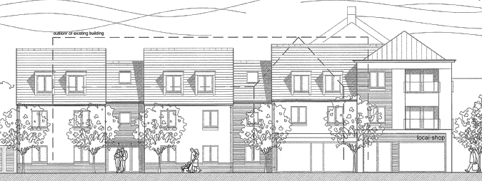
Approved Copse Lane Elevation

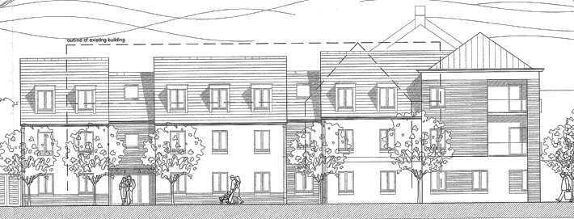
Proposed Copse Lane Elevation

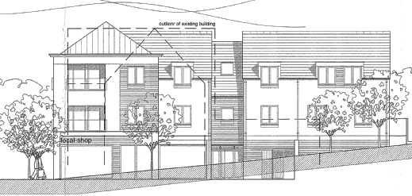
Approved Eden Drive Elevation

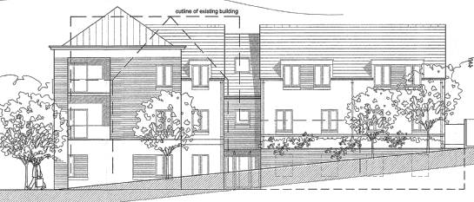
Proposed Eden Drive Elevation

14. The Committee will note that the most obvious change is the turret element. This has been increased in size slightly, which in itself is not significant. However, its materials give it a denser appearance. Officers raise no objection to the principle of its size, however, the use of the correct materials, and in particular their arrangement, will be essential to the success of this element of the building. Officers recommend a condition which requires samples of materials to be submitted for agreement, and that their arrangement within the turret element is reviewed.

Parking/Highways
- At the time of drafting this report the Highway Authority have not provided comments. Officers will update the Committee at the meeting. However, in the absence of those comments officers can confirm that the site will be removed from the controlled parking zone and with that future residents and visitors will not be eligible to parking permits. In addition a condition is recommended to ensure that future residents, through tenancy agreements, are required not to bring cars into the City.

- The application proposes 62 cycle parking spaces in secure areas, whilst there is in addition 18 visitor cycle parking spaces proposed on the Copse Lane frontage. This level of provision greatly exceeds the requirements of the Oxford Local Plan.

- There is likely to be an increase in cycle generation and in line with the Planning Obligations Supplementary Planning Document a contribution of £8,004 will be required towards improving the cycle network to and from the colleges.

Planning Obligations
- In addition to the cycle safety contribution further contributions are required to mitigate the impact of the proposals on City and County Services and infrastructure. The contributions set out above are indexed linked to values at 2006 levels and should be increased accordingly to the real value at the time of payment. As a result of the size of the units proposed the contributions have been calculated on the basis of 58 additional students. These contributions will need to be secured by legal agreement prior to any grant of planning permission.

Ecology
- The site is within close proximity to the New Marston Meadows Site of Scientific Interest. However, due to the nature and scale of the proposal, Natural England has raised no objection to the proposed application. Officers therefore consider the scheme to be acceptable in relation to ecology.

Conclusion: The principle of development was established in granting the previous application. The differences between that scheme and the proposed scheme, as set out above, are not considered to give rise to unacceptable adverse impacts that could not be mitigated by condition or obligation. Officers therefore consider the application to be acceptable and would recommend that Committee resolve to grant planning permission but to delegate authority to officers to issue the permission on completion of the legal agreement to secure the above contributions, and subject to the conditions set out above.

Human Rights Act 1998

Officers have considered the Human Rights Act 1998 in reaching a recommendation to grant planning permission, subject to conditions. Officers have considered the potential interference with the rights of the owners/occupiers of surrounding properties under Article 8 and/or Article 1 of the First Protocol of the Act and consider that it is proportionate.

Officers have also considered the interference with the human rights of the applicant under Article 8 and/or Article 1 of the First Protocol caused by imposing conditions. Officers consider that the conditions are necessary to protect the rights and freedoms of others and to control the use of property in accordance with the general interest. The interference is therefore justifiable and proportionate.

Section 17 of the Crime and Disorder Act 1998

Officers have considered, with due regard, the likely effect of the proposal on the need to reduce crime and disorder as part of the determination of this application, in accordance with section 17 of the Crime and Disorder Act 1998. In reaching a recommendation to grant planning permission, officers consider that the proposal will not undermine crime prevention or the promotion of community safety.

Background Papers: 11/01681/FUL, 10/03215/FUL

Contact Officer: Steven Roberts
Extension: 2221
Date: 20th July 2011

Appendix 1

Site location Plan

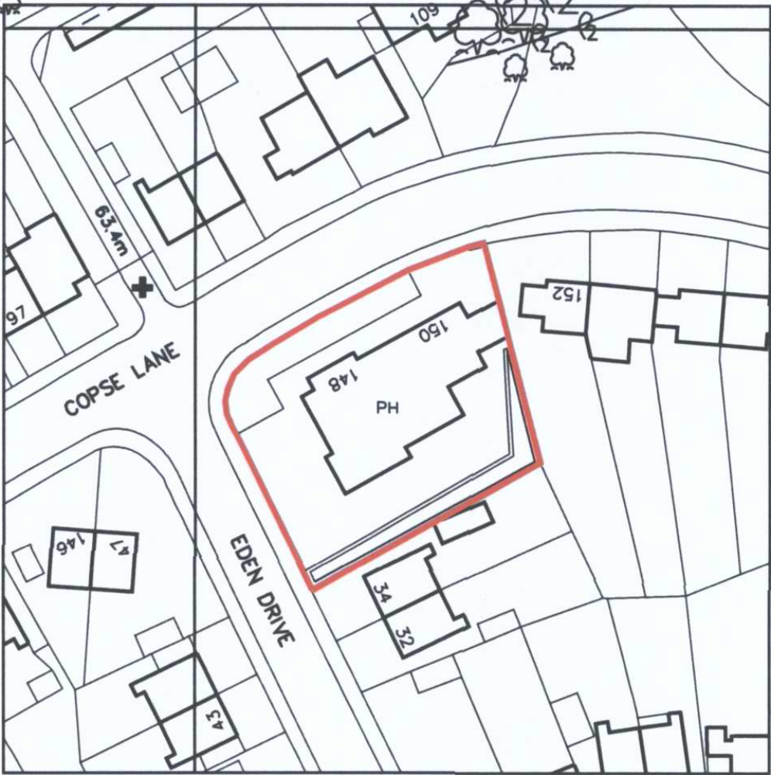

Appendix 2

North East Area Committee | - 19th April 2011

Application Number: | 10/03215/FUL
Decision Due by: | 2nd March 2011
Proposal: | Demolition of existing public house. Erection of two and three storey building accommodation for retail store and 35 student study bedrooms. Provision of bin and cycle storage. (Amended Plans)
Site Address: | The Cavalier Public House 148-150 Copse Lane Oxford Oxfordshire
Ward: | Headington Hill And Northway Ward

Agent: | John Philips Planning Consultancy | Applicant: | I And O Limited

This report should be read in conjunction with the officer’s report to the North East Area Committee dated 17th March 2011 (attached as appendix 1).

At the meeting of the 17th March 2011 the committee resolved to defer the application to allow officers to discuss with the Highway Authority concerns raised regarding highway safety and possible conflict with New Marston Primary School in the event that the school expands in the future.

The highway authority has been reconsulted and they maintain their position of no objection. They have stated that it would not be reasonable to take into consideration the possible expansion of New Marston Primary School when no firm proposal is in place. They have confirmed that there are presently the following highway safety measures in place at this location:

  - ‘School Keep Clear’ markings on the carriageway
  - Double yellow lines indicating no parking or waiting on the school side of the road
  - School Crossing patrol; at start and end of school times
  - ‘Slow’ sign on carriageway at approach to school
  - Flashing lights operated by patrol and school signage
  - 20mph speed limits

In addition to these safety measures the applicant has offered to provide financial contributions towards two Vehicle Activated Speed signs, to be placed near to the school. The highway authority supports this approach. It should also be noted that the pub could be converted into a retail shop without the need for planning permission, in the event of which the various benefits of the application could not be secured.

In the light of the maintained support of the highway authority and the additional safety measures offered by the applicant, officers raise no objection to the proposal on highway safety grounds. Officers would however, in addition to the conditions and obligations set out in the report attached as appendix 1, add a further obligation requiring the payment of £5,000 towards the two Vehicle Activated Speed signs.

Background Papers: 10/03215/FUL

Contact Officer: Steven Roberts
Extension: 2221
Date: 5th April 2011

North East Area Committee | - 15th March 2011

Application Number: | 10/03215/FUL
Decision Due by: | 2nd March 2011
Proposal: | Demolition of existing public house. Erection of two and three storey building accommodation for retail store and 35 student study bedrooms. Provision of bin and cycle storage. (Amended Plans)
Site Address: | The Cavalier Public House 148-150 Copse Lane Oxford (Site Location – Appendix 1)
Ward: | Headington Hill And Northway Ward

Agent: | John Philips Planning Consultancy | Applicant: | I And O Limited

Recommendation: Resolve to grant planning permission and delegate authority to officers to issue the decision notice upon completion of the Legal Agreement. For the following reasons:

1 The proposal is considered to be an efficient and appropriate use of the site according with Local Plan policy CP6, HS14 and RC8. The matters of management of the student accommodation can be adequately controlled by condition as advocated by policy HS14. The loss of the public house has been justified and in the context of the proposals, that comply with the Councils above land use policies, is acceptable in accordance with Local Plan policy RC18. The scale, form and appearance of the new building would relate to its context and would offer enhancements to the public realm through landscaping and tree planting on this prominent corner in accordance with Local Plan policy CP1, CP6, CP7, CP8, CP9, CP10 and CP11. The proposal would preserve the residential amenities of neighbouring properties in accordance with Local Plan policy CP10 and HS19.

2 Officers have considered carefully all objections to these proposals. Officers have come to the view, for the detailed reasons set out in the officers report, that the objections do not amount, individually or cumulatively, to a reason for refusal and that all the issues that have been raised have been adequately addressed and the relevant bodies consulted. Specific matters relating to parking can be adequately controlled through a condition removing the site from the Controlled Parking Zone. This approach is consistent with Local Plan policy HS14.

3 The Council considers that the proposal accords with the policies of the development plan as summarised below. It has taken into consideration all other material matters, including matters raised in response to consultation and publicity. Any material harm that the development would otherwise give rise to can be offset by the conditions imposed.

subject to the following conditions, which have been imposed for the reasons stated:-

1 Development begun within time limit
2 Develop in accordance with approved plans
3 Site Levels
4 Full Time Students Only
5 Details of Management Agent on Building
6 On site Warden
7 Housing Management Service Specification
8 No Amplified Music Audible Outside Building between 00.00 and 8.00
9 External Lighting Scheme
10 Sample External Materials
11 Boundary details before commencement
12 Landscape plan required
13 Tree Planting Details
14 Landscape Carry out by completion
15 Landscape management plan
16 Bin and Cycle Storage
17 Sustainable Drainage Scheme
18 No Student Cars
19 Construction Traffic Management Plan
20 Details of Mechanical Plant
21 Suspected contamination - Risk assess
22 Variation of Road Traffic Order

Legal Agreements:
1 - Contribution towards the Library service - £1,832
2 – Contribution towards Indoor Sports Facilities - £2,100
3 - Contribution towards cycle safety measures - £4,830

Main Local Plan Policies:
Oxford Local Plan 2001-2016 (OLP)

CP1 - Development Proposals
CP2 - Planning Obligations
CP3 - Limiting the Need to Travel
CP5 - Mixed-Use Developments
CP6 - Efficient Use of Land & Density
CP7 - Urban Design
CP8 - Design Development to Relate to its Context
CP9 - Creating Successful New Places
CP10 - Siting Development to Meet Functional Needs
CP11 - Landscape Design
CP12 - Designing out Crime
CP15 - Energy Efficiency
CP16 - Renewable Energy
TR3 - Car Parking Standards
TR4 - Pedestrian & Cycle Facilities
HS14 - Speculative Student Accommodation
HS19 - Privacy & Amenity
CP20 - Lighting
CP21 – Noise
RC8 – Neighbourhood Shopping Centres
RC9 - Individual Shops
RC18 - Public Houses

Core Strategy – Proposed Changes

CSP18 - Infrastructure & Developer contributions
CSP19 - Urban design townscape char & historic environment
CSP26 - Student accommodation
CSP32 - Retail

Other Material Considerations:
- PPS 1 – Delivering Sustainable Development
- PPS 4 – Planning for Sustainable Economic Growth
- PPG 13 – Transport
- Planning Obligations-Supplementary Planning Document
- Parking Standards, Transport Assessments and Travel Plans-Supplementary Planning Document

Relevant Site History: None

Representations Received: The following comments have been received:

Derwent Avenue: 57, 59, 61

Coniston Avenue: 72

Copse Lane: New Marston Primary School

- Increase in traffic
- Risk to pupils of New Marston Primary School resulting from additional traffic
- No need for more shops in this area
- Design is visually sensitive and could add to the area.
- Site on blind bend, opposite school and public open space. Risk of conflict with people and vehicles. No need for new shop
- Too many students in the area already. Affordable housing would be better
- The shop could compromise viability of other shops in the area
Statutory and Internal Consultees:
Highways and Traffic – No objection subject to conditions and contributions towards cycle safety measures within the area. See officers assessment below for more detail.
Environmental Health – No objections subject to conditions relating to land remediation.

Thames Water Utilities Limited – No objections relating to surface water drainage and water.

Issues:
- Loss of Public House
- Retail
- Student Accommodation
- Form and Appearance
- Impact on Neighbouring Properties
- Parking and Traffic
- Planning Obligations

Officers Assessment:

Site Description and Proposal
- The application site comprises the Cavalier Public House, located on the junction of Copse Lane and Eden Drive. The existing building sits prominently within the site and stands at two storeys in height. The prominence is increased by the plinth beneath the building which increases its overall height and the gable features on the Copse Lane and Eden Drive corner of the building. The site is vacant but when operational the public house was served by car parking to the front and rear along with a small beer garden also at the rear.

- The area is predominately residential and is characterised by the two storey residential properties set back from the footway behind low boundary walls or fences and front gardens. The land rises sharply to the south of Copse Lane and as a result the buildings on the south side of the road are set at a higher level than the street.

- The application proposes the demolition of the existing building and the erection of a two and partly three storey building. On the ground floor the new building will accommodate approximately 2500sqft of retail space, 7 student study bedrooms, two cycle stores accommodating 15 cycle parking spaces as well as bin storage for the students, and bin storage for the retail unit. On the 1st and 2nd floor the building will accommodate a further 28 student study bedrooms.

- Further to the above, the proposals also involve public realm improvements with the new hard landscaping and tree planting along both road frontages, the realignment of the footpath along Copse Lane and provision of new lay-by parking, which will also serve as a delivery bay.
Loss of the Public House
- Local Plan policy RC18 relates to the loss of public houses and states that this will only be acceptable if one or more of the following criteria are met:

  - No other potential occupier can be found following a realistic marketing exercise
  - Substantial evidence of non-viability has been submitted
  - Alternative public houses to meet the needs of the local community

- In regard to criterion (a) the site has been marketed by Savills since the start of 2010. The marketing particulars indicate that it was marketed as a development opportunity and the guide price of £400,000 probably reflects this. No detailed evidence has been provided in relation to the level of interest in the premises for a public house use and therefore officers are not of the view that criterion (a) has been satisfied.

- The application is accompanied by a Viability Assessment produced by Thomas E. Teague. This document provides a detailed analysis and uses CAMRA’s Public Housing Viability Test. The report indicates that sales have declined significantly since 2006 and that weekly alcohol sales had before closure fallen below £1000. The report also concludes that the site would not lend itself well as a destination pub. Whilst it is of reasonable size, has off street car parking and a beer garden, officers would agree with the conclusion that at this location the premises would be highly unlikely to become a destination pub. In this regard and considering the conclusion of the viability test officers are of the view that the applicant has demonstrated the non-viability of the premises as set out in criterion (b) of local plan policy RC18.

- In regard to criterion (c) the applicant has made reference to eight pubs within approximately 1 mile of the application site. Whilst this seems like a wide area of search officers are of the view that as a local community public house the non-viability of the premises demonstrates that the community would travel to visit public houses. In this regard the search area adopted by the applicant is probably a fair reflection. The site is also highly sustainable with excellent bus links and cycle routes. Officers therefore consider that criterion (c) of policy HS18 has been satisfied.

- In the light of the above officers are of the view the loss of the public house, within the context of the proposals is acceptable.

Retail
- The starting point in considering the retail element of the proposals is PPS4 - Planning for Sustainable Economic Growth. The main trust of PPS4 is to support local centres and promote consumer choice. It supports proposals that seek to strengthen the vitality of local centres. The application site is approximately 300m away from the Cherwell Drive Neighbourhood Shopping Centre which is between the junction of Copse Lane and Marsh Lane, with the petrol station opposite also forming part of the small commercial centre.

- The proposed shop unit whilst having a modest amount of car parking (4 spaces) is for all intent and purposes a community shop. The unit is not of a scale that it would detract from the main shopping centre of Headington and in relation to the Cherwell Drive shopping area the proposed retail unit would as advocated by PPS4 offer further choice therefore reinforcing the vitality of the centre rather than detracting from it. In this regard officers raise no objection to the retail element of the proposals.

Student Accommodation
- The City Council wishes to see an increase in the proportion of university students housed in purpose built accommodation. Local Plan policy HS14 states that planning permission will only be granted for speculative developments when there are adequate occupancy restrictions, that there are appropriate management controls in place and measures to prevent occupiers from bringing cars into the City, and that the development would not unacceptably affect the amenities of local residents. These measures can be secured by condition and this approach is consistent with policy HS14.

- Officers recognise the general local concern that student accommodation within residential areas can lead to noise and disturbance and a perceived imbalance in the population. However, there is no technical evidence to support the latter view, nor does policy HS14 raise the population mix as an issue that should be considered in assessing applications for purpose built accommodation in residential areas. The purpose of the accommodation is to remove students from market housing rather than increasing overall numbers.

- In relation to the matter of noise and disturbance officers would point to the existing use and that a public house by its very nature can result in a high level of activity. A residential block in contrast would be an improvement in this regard and it is important to draw a distinction between students that live in rented houses and those that reside in purpose built accommodation. The latter offers the opportunity to house students in one place where management controls can be secured and enforced. This would be achieved by condition as advocated by policy HS14.

- The site is highly sustainable in that it has good transport links along with access to local services and shops. In addition it is ideally placed for students studying in Headington. In this regard subject to the above matters being controlled by condition and that the site be removed from the Controlled Parking Zone to prevent future residents from having cars, officers would raise no objection to the proposed student use.

Form and Appearance
- Copse Lane is predominantly residential in use and the properties are traditional in architectural form and appearance, being largely two storeys in height. However, due to the increase in gradient from north to south, the properties on the southern side of Copse lane stand higher than the road. Along Eden Drive this change in level is more obvious and as a result the ground level of No 34 Eden Drive, immediately to the north of the application site, is approximately 2.5m higher than Copse Lane.

- Due to the change in levels and the size of the existing pub, which incorporates prominent gables on the Copse Lane and Eden Drive corner, the building stands prominently within the street. Apart from its prominence, which makes the pub a focal point, the building is not of any significant architectural merit. Officers are therefore of the view that its replacement with a well designed and sensitive scheme that would meet the Councils other policy objectives would be acceptable.

- In plan form the proposed building is ‘L’ shaped with development focused along the two road frontages. The Copse Lane elevation stands at two storeys, rising to three storeys at the northeast corner adjacent to the road junction. The Eden Drive elevation is two and a half storeys, although part of this is below street level due to the change in levels along Eden Drive.

- The proposals have sought to use the change in levels to maximise the level of development whilst not appearing out of context. At its ridge therefore the three storey element is only 0.5m higher than the existing pub, although its eaves are actually 1.8m lower. As a result of this the three storey part of the building would be seen in much the same way, in scale terms, to the two prominent gable features on the northwest corner of the existing building.

- The proposed building in response to its traditional context incorporates a pitch roof and uses materials common to the area, i.e. brick, tile and render. Whilst not deviating from this design approach, the two street frontages have been treated slightly differently due to the different levels. The Copse Lane elevation takes its lead from the adjoining row of houses, being positioned along a similar building line and incorporating set backs at regular intervals which break up the mass of the elevation. The activity of the frontage and alterations to the public realm, with new landscaping and tree planting, would be of benefit to the streetscape.

- The Eden Drive elevation is two and a half storeys in height, although at street level this appears less due to the change in levels. The building uses a similar theme to the Copse Lane elevation, incorporating a set back to break up the elevation thus reducing its mass. However the challenge is how to work with the levels whilst not appearing out of place within the streetscene. The proposal attempts to work with the changing levels and as such is set down from No 34 Eden Drive. The elevation therefore appears as a continuation, albeit more contemporary, of the streetscene.
- In consideration of the objectives of Local Plan policy CP8 and CP10, which requires development to appreciate its context by creating an appropriate visual relationship with the form, grain, scale, materials and details of the surrounding area, and in doing so maintaining, enhancing or creating street frontages, officers consider the proposals to be an appropriate response to the characteristics of the area. Whilst the proposal will introduce a larger building than is on site at present, for the reasons set out above and the in the light of the opportunity for tree planting to soften the building edge, officers are satisfied that in visual terms the proposal will be acceptable.

Impact on Neighbouring Properties
- Policy HS19 states that planning permission will only be granted for developments that adequately provide for the protection of the privacy or amenity of the occupants of the proposed and existing neighbouring residential properties.

- By reason of the existing and proposed building/use there will inevitably be an impact on neighbouring properties. This is not however to say that the impact would be unacceptably harmful. The impact of the proposed uses has been addressed above and officers will not therefore go into this issue again.

- The ‘L’ shaped layout apart from providing active frontages along both roads also ensures that the proposed building does not impinge upon the daylight to the rear gardens or windows of adjoining properties to an unacceptable degree. The 45degree rule would be complied with.

- In relation to privacy the new building along both frontages of the site introduces rear facing windows that will be directed towards the rear gardens of Nos 34 Eden Drive and No 152 Copse Lane. Rear windows of the Copse Lane wing are landing windows and are in excess of 18m away from the boundary. In addition due to the difference in levels the opportunity to gain views into the rear garden of No 34 Eden Drive would be minimal. The applicant has nevertheless proposed tree planting along the boundary to maintain privacy.

- The rear facing windows of the Eden Drive wing are habitable, however they are in excess of 17m away from the boundary and due to levels and existing and proposed boundary treatment overlooking would not be significant to the living conditions of the adjoining property.

Parking and Traffic
- The application is accompanied by a Transport Statement to compare the existing traffic movements and the proposed movements to/from the site. With regard to the existing pub, which is now closed, the consultants have looked at sites elsewhere in the country and compared their traffic characteristics and used the trips to predict the Cavalier PH movements. The figures show that on a daily basis a public house of this size operating fully would generate around 250 movements.

- The new development of a retail unit and student bedrooms will generate more trips according to this information but all if not most would be pass by trips or linked trips, that is trips already on the network and calling by for goods associated with the convenience store etc. The numbers of trips anticipated are relatively low and due to its location within a residential area with good public transport links it is expected that a large number of shoppers would be local. The student accommodation would be car free and would therefore not generate any movements except for those associated with the disabled space and maintenance.

- There is likely to be an increase in cycle generation and in line with the Planning Obligations Supplementary Planning Document a contribution of £4968.00 (£138 x number of rooms 36) will be required towards improving the cycle network to and from the colleges.

- At present adjoining the site fronting on to Copse Lane there is a space which is taken up with parking and at times there are 4 to 5 vehicles parked on this area. The proposals incorporate changes to the highway to accommodate a lay-by on Copse Lane for short time customer parking and for delivery and service vehicles. With the creation of a proposed delivery zone and parking this will be a benefit as cars and customer parking will take place within this area.

- Given the busy nature of the adjacent highway network and the proximity of New Marston Primary School, a Construction Traffic Management Plan will be required to be submitted for consideration and approval before implementation of any permission that may be granted. Officers would recommend a condition to secure this detail.

- In the light of the above the County Council as Highway Authority raise no objection to the proposal.

Planning Obligations
- In addition to the cycle safety contribution further contributions are required to mitigate the impact of the proposals on City and County Services and infrastructure. The contributions set out above are indexed linked to values at 2006 levels and should be increased accordingly to the real value at the time of payment. As a result of the size of the units proposed the contributions have been calculated on the basis of 35 additional students. These contributions will need to be secured prior to any grant of planning permission.

Conclusion: The proposal is considered to be an efficient and appropriate use of the site. Whilst the loss of the pub is regrettable its loss has been justified and the replacement uses are consistent with the Councils land use policies relating to retail and student accommodation. The scale, form and appearance of the new building would relate to its context and would offer enhancements to the public realm through landscaping and tree planting. The proposal would preserve the residential amenities of neighbouring properties.

In the light of the above officers consider that on balance the proposals are acceptable and accord with the Local Plan. The Committee is therefore recommended to resolve to grant planning permission but to delegate authority to issue the permission to officers on completion of the legal agreement to secure the above contributions.

Human Rights Act 1998

Officers have considered the Human Rights Act 1998 in reaching a recommendation to grant planning permission, subject to conditions. Officers have considered the potential interference with the rights of the owners/occupiers of surrounding properties under Article 8 and/or Article 1 of the First Protocol of the Act and consider that it is proportionate.

Officers have also considered the interference with the human rights of the applicant under Article 8 and/or Article 1 of the First Protocol caused by imposing conditions. Officers consider that the conditions are necessary to protect the rights and freedoms of others and to control the use of property in accordance with the general interest. The interference is therefore justifiable and proportionate.

Section 17 of the Crime and Disorder Act 1998

Officers have considered, with due regard, the likely effect of the proposal on the need to reduce crime and disorder as part of the determination of this application, in accordance with section 17 of the Crime and Disorder Act 1998. In reaching a recommendation to grant planning permission, officers consider that the proposal will not undermine crime prevention or the promotion of community safety.

Background Papers: 10/03215/FUL

Contact Officer: Steven Roberts
Extension: 2221
Date: 28th February 2011

